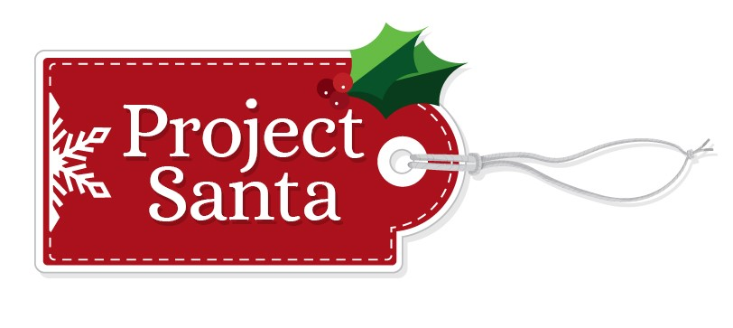
October 2024

Dear Project Santa Helpers,

The holidays will be here soon. The Committee is gearing up to start our annual Project Santa Program which helps families facing difficult economic times have a nice Christmas. Project Santa offers businesses, organizations, families and individuals a way to get involved and spread the holiday spirit.

If you or your business are interested in adopting a family or donating individual toys, please fill out the form below and mail to Project Santa, P.O. Box 455, Windsor, CT, or email info@projectsantawindsor.org

If you have resources, we ask that you sponsor more families/children so that no child goes without. Please include wrapping paper, gift bags and tape so that the family can wrap their presents. If possible, please include a gift receipt for any clothing. As always, a grocery store or gas gift card is a great addition and is very much appreciated.

We look forward to hearing from you, and we will be in touch as time gets closer to match your requests with the children and families in the program. For planning purposes, gifts will be due on December 6 & 7 at Grace Church in Windsor Center.

I look forward to hearing from you soon and working together to bring joy to Windsor Children. If you have any questions call me at 860-882-8842 or email me at
info@projectsantawindsor.org

Thank you,

Jane Garibay, Chairperson
Project Santa Committee
860-882-8842

Project Santa Sign Up Form
Please fill out completely and mail to P.O. Box 455, Windsor CT 06095
Or sign up online at www.projectsantawindsor.org and click on the sponsor button!

Contact Name:________________________________________________

Business Name:_______________________________________________

Mailing Address:________________________________________________

Phone Number:_________________ Email:_______________________

Please check your choice:
_____ Sponsor _____ # of family/families OR _____# of children

_____ Donate a variety of toys, clothes or grocery/gas gift cards

_____Donate money for another Santa’s Helper to go shopping

Method of Payment
To submit payment with application, use the form below.

- Check is enclosed.
◻ Visa, MasterCard, Discover, AMEX Exp. Date ______ CVV ______
Credit Card Number _________________________________
Authorized Signature: _________________________________
Name on Card (please print): ______________________________
Address on Card (if different from above)
Address:____________________________________________

Project Santa is a 501C3 and your contribution is tax deductible. Our EIN # is 81-3927240. Please keep your receipts and staple to a copy of this form.

